**Task 1**

**Query 1**

Model : SIFT k: 20 Technique: Singular value decomposition (SVD)

Refer to the file datasemantic_task1_query1.html in the folder Output/HTML Files.

Refer to the file featuresemantic_task1_query1.html in the folder Output/HTML Files.

**Query 2**

Model : SIFT k: 40 Technique : Singular value decomposition (SVD)

Refer to the file datasemantic_task1_query2.html in the folder Output/HTML Files.

Refer to the file featuresemantic_task1_query2.html in the folder Output/HTML Files.

**Query 3**

Model : Color Moments k: 20 Technique: LDA

Refer to the file datasemantic_task1_query3.html in the folder Output/HTML Files.

Refer to the file featuresemantic_task1_query3.html in the folder Output/HTML Files.

**Query 4**

Model : Color Moments k: 40 Technique : LDA

Refer to the file datasemantic_task1_query4.html in the folder Output/HTML Files.

Refer to the file featuresemantic_task1_query4.html in the folder Output/HTML Files.

**Task 2**

**Query 1**

K : 10 M : 10 Image ID : Hand_0000111.jpg Technique : Principal component analysis (PCA)

ImageId:Hand_0000111.jpg Score:0.000000

ImageId:Hand_0000112.jpg Score:5.925817

ImageId:Hand_0000108.jpg Score:6.846490

ImageId:Hand_0001145.jpg Score:17.547246

ImageId:Hand_0001144.jpg Score:19.311032

ImageId:Hand_0001091.jpg Score:32.391096

ImageId:Hand_0001154.jpg Score:35.304660

ImageId:Hand_0001153.jpg Score:36.558831

ImageId:Hand_0000990.jpg Score:39.951792

ImageId:Hand_0001324.jpg Score:40.923982

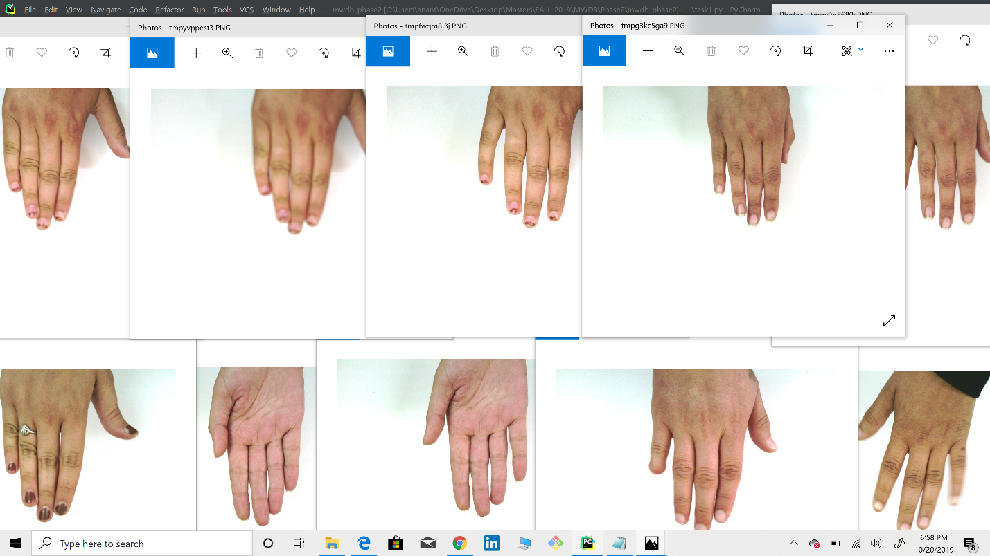

**Query 2**

Model : HOG K : 40 M : 10 Image ID : Hand_0000111.jpg

Technique : Principal component analysis (PCA)

ImageId:Hand_0000111.jpg Score:0.000000

ImageId:Hand_0000112.jpg Score:16.188631

ImageId:Hand_0000108.jpg Score:27.056813

ImageId:Hand_0001145.jpg Score:37.373170

ImageId:Hand_0001144.jpg Score:45.054504

ImageId:Hand_0001091.jpg Score:49.636455

ImageId:Hand_0001092.jpg Score:60.161197

ImageId:Hand_0001325.jpg Score:66.725578

ImageId:Hand_0000132.jpg Score:68.750755

ImageId:Hand_0001324.jpg Score:70.791631

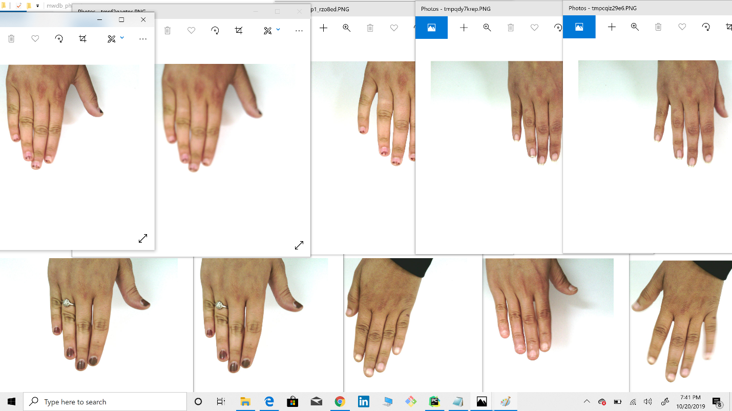

**Query 3**

Model : LBP K : 10 M : 10 Image ID : Hand_0000200.jpg

Technique: Non-negative matrix factorization (NMF)

ImageId:Hand_0000200.jpg Score:0.000000

ImageId:Hand_0000330.jpg Score:0.328226

ImageId:Hand_0000199.jpg Score:0.457021

ImageId:Hand_0000488.jpg Score:0.478226

ImageId:Hand_0000282.jpg Score:0.701752

ImageId:Hand_0000490.jpg Score:1.300131

ImageId:Hand_0000491.jpg Score:1.500885

ImageId:Hand_0000329.jpg Score:1.606854

ImageId:Hand_0000283.jpg Score:1.629197

ImageId:Hand_0001466.jpg Score:1.648980

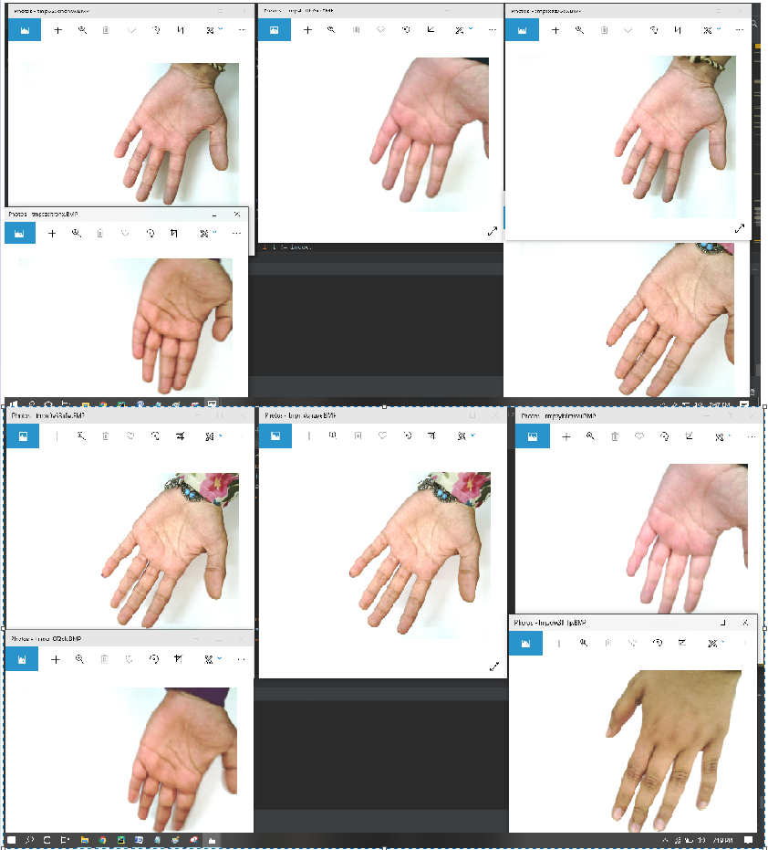

**Query 4**

Model : LBP K : 40 M : 10 Image ID : Hand_0000200.jpg

Technique : Non-negative matrix factorization (NMF)

ImageId:Hand_0000200.jpg Score:0.000000

ImageId:Hand_0000199.jpg Score:1.786988

ImageId:Hand_0000330.jpg Score:2.064967

ImageId:Hand_0000488.jpg Score:2.555205

ImageId:Hand_0000204.jpg Score:3.405612

ImageId:Hand_0000205.jpg Score:3.495886

ImageId:Hand_0000282.jpg Score:3.747003

ImageId:Hand_0011158.jpg Score:3.927982

ImageId:Hand_0000329.jpg Score:3.966061

ImageId:Hand_0011159.jpg Score:4.014334

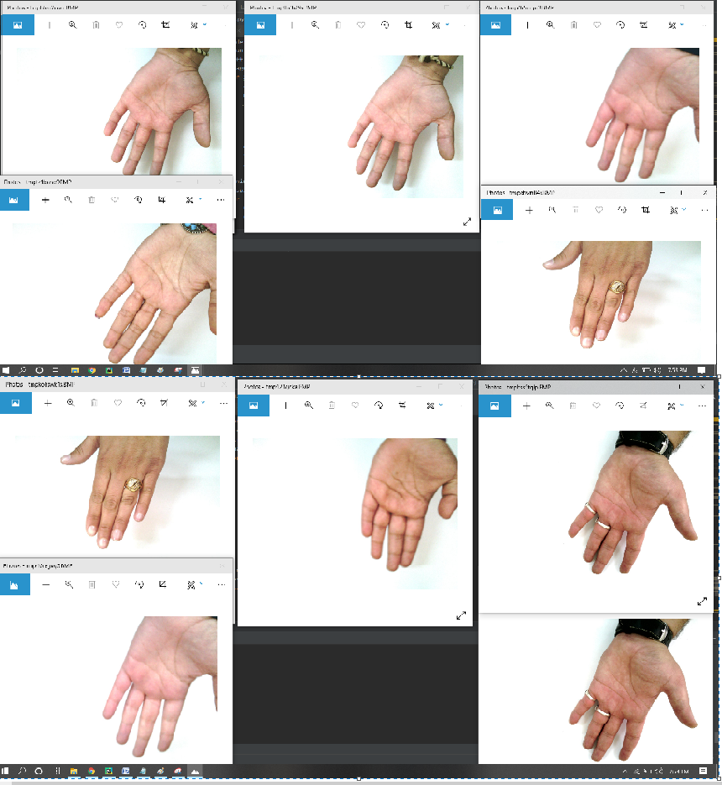

**Task 3**

**Query 1**

Model : HOG K : 20 Label : Dorsal Technique : Principal component analysis (PCA)

Refer to the file datasemantic_task3_query1.html in the folder Output/HTML Files.

Refer to the file featuresemantic_task3_query1.html in the folder Output/HTML Files.

**Query 2**

Model : HOG K : 30 Label : Dorsal Technique: Principal component analysis (PCA)

Refer to the file datasemantic_task3_query2.html in the folder Output/HTML Files.

Refer to the file featuresemantic_task3_query2.html in the folder Output/HTML Files

**Query 3**

Model : Color Moments K : 20 Label : Left Technique: Latent dirichlet analysis (LDA)

Refer to the file datasemantic_task3_query3.html in the folder Output/HTML Files.

Refer to the file featuresemantic_task3_query3.html in the folder Output/HTML Files.

**Query 4**

Model : Color Moments K : 30 Label : Left Technique: Latent dirichlet analysis (LDA)

Refer to the file datasemantic_task3_query4.html in the folder Output/HTML Files.

Refer to the file featuresemantic_task3_query4.html in the folder Output/HTML Files.

**Task 4**

**Query 1**

Model : LBP K : 10 M : 10 Label : Palmer Technique : Non-negative matrix factorization (NMF)

Image ID : Hand_0000200.jpg

ImageId:Hand_0000200.jpg Score:0.000000

ImageId:Hand_0000330.jpg Score:0.328226

ImageId:Hand_0000199.jpg Score:0.457021

ImageId:Hand_0000488.jpg Score:0.478226

ImageId:Hand_0000282.jpg Score:0.701752

ImageId:Hand_0000490.jpg Score:1.300131

ImageId:Hand_0000491.jpg Score:1.500885

ImageId:Hand_0000329.jpg Score:1.606854

ImageId:Hand_0000283.jpg Score:1.629197

ImageId:Hand_0001466.jpg Score:1.648980

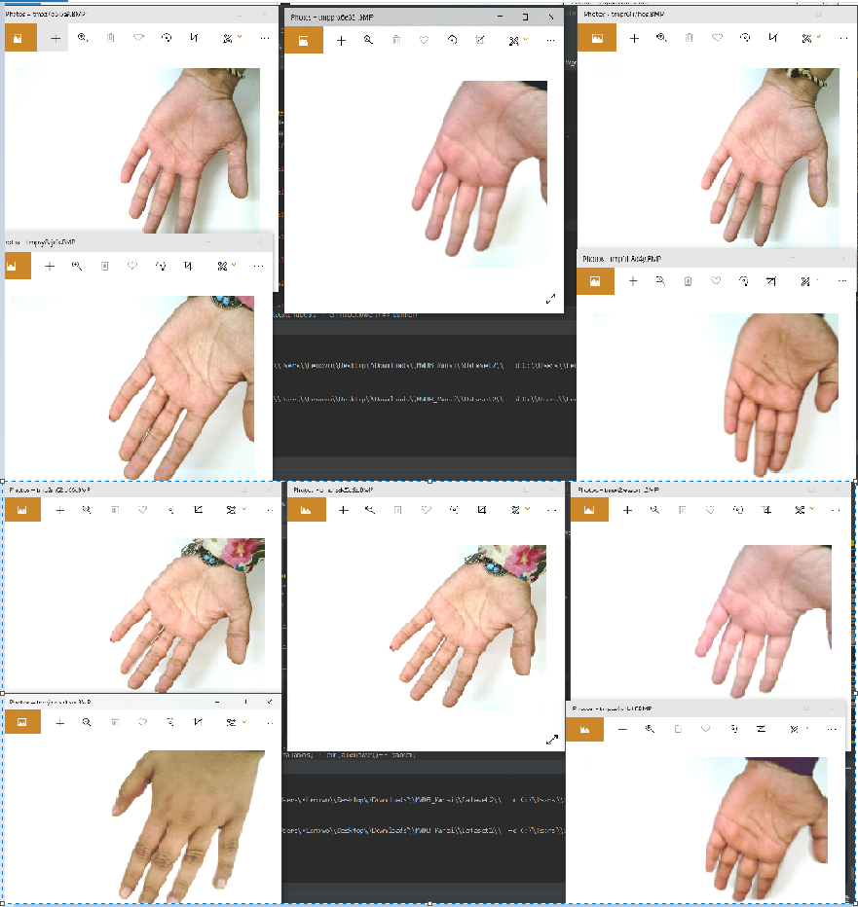

**Query 2**

Model : LBP K : 30 M : 10 Label :Palmer Technique: Non-negative matrix factorization (NMF)

Image ID : Hand_0000200.jpg

ImageId:Hand_0000200.jpg Score:0.000000

ImageId:Hand_0000199.jpg Score:1.020905

ImageId:Hand_0000488.jpg Score:1.827584

ImageId:Hand_0000330.jpg Score:1.937412

ImageId:Hand_0000282.jpg Score:3.034903

ImageId:Hand_0000490.jpg Score:3.041869

ImageId:Hand_0000204.jpg Score:3.521146

ImageId:Hand_0000205.jpg Score:3.728970

ImageId:Hand_0000329.jpg Score:3.747792

ImageId:Hand_0000491.jpg Score:3.757151

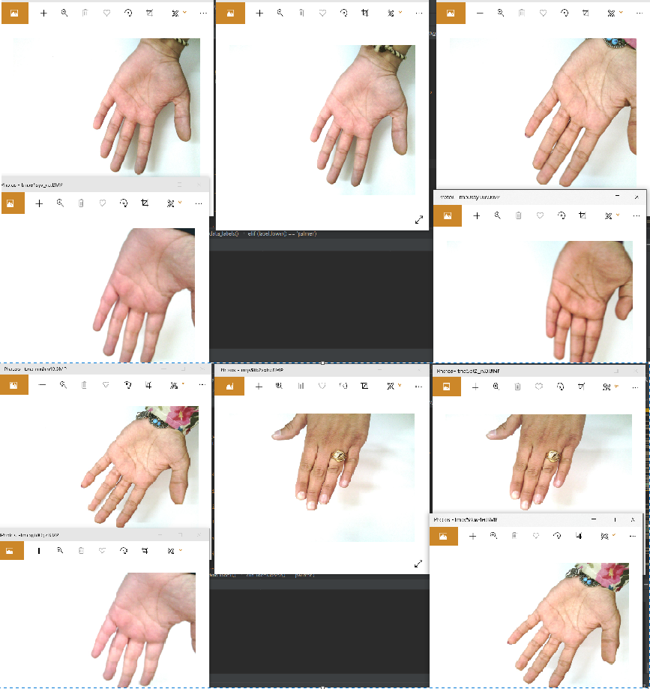

**Query 3**

Model : Sift K : 10 M : 10 Label : With Accessories Technique: Singular value decomposition (SVD)

Image ID : Hand_0011160.jpg

ImageId:Hand_0011160.jpg Score:0.000000

ImageId:Hand_0001538.jpg Score:0.335686

ImageId:Hand_0000488.jpg Score:0.344334

ImageId:Hand_0001395.jpg Score:0.376794

ImageId:Hand_0001103.jpg Score:0.379015

ImageId:Hand_0000934.jpg Score:0.383742

ImageId:Hand_0000935.jpg Score:0.387124

ImageId:Hand_0011106.jpg Score:0.394424

ImageId:Hand_0001539.jpg Score:0.409299

ImageId:Hand_0000270.jpg Score:0.416621

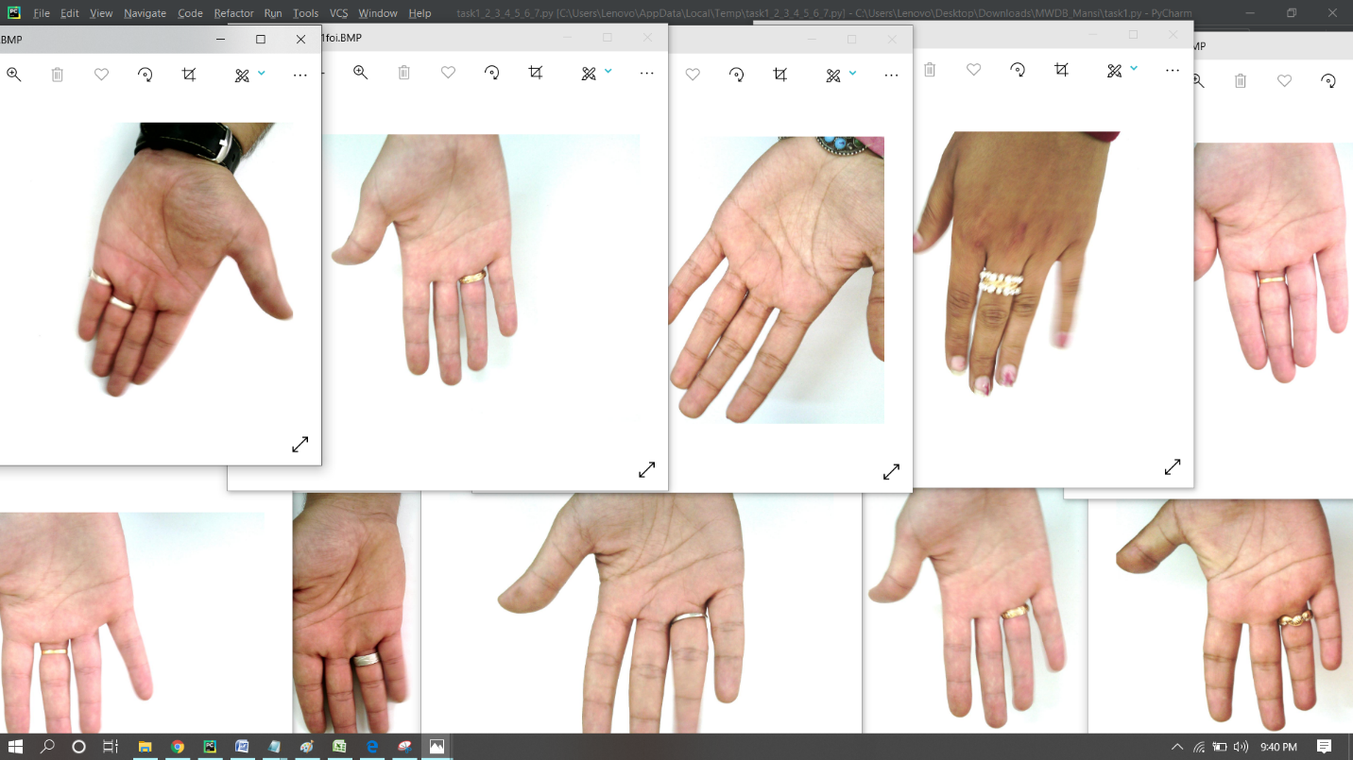

**Query 4**

Model : Sift K : 30 M : 10 Label : With Accessories Technique: Singular value decomposition (SVD)

Image ID : Hand_0011160.jpg

ImageId:Hand_0011160.jpg Score:0.000000

ImageId:Hand_0000483.jpg Score:0.832808

ImageId:Hand_0011158.jpg Score:0.848672

ImageId:Hand_0000929.jpg Score:0.863594

ImageId:Hand_0001428.jpg Score:0.906966

ImageId:Hand_0000934.jpg Score:0.923949

ImageId:Hand_0000488.jpg Score:0.943051

ImageId:Hand_0000410.jpg Score:0.946401

ImageId:Hand_0001538.jpg Score:0.969503

ImageId:Hand_0001533.jpg Score:0.971742

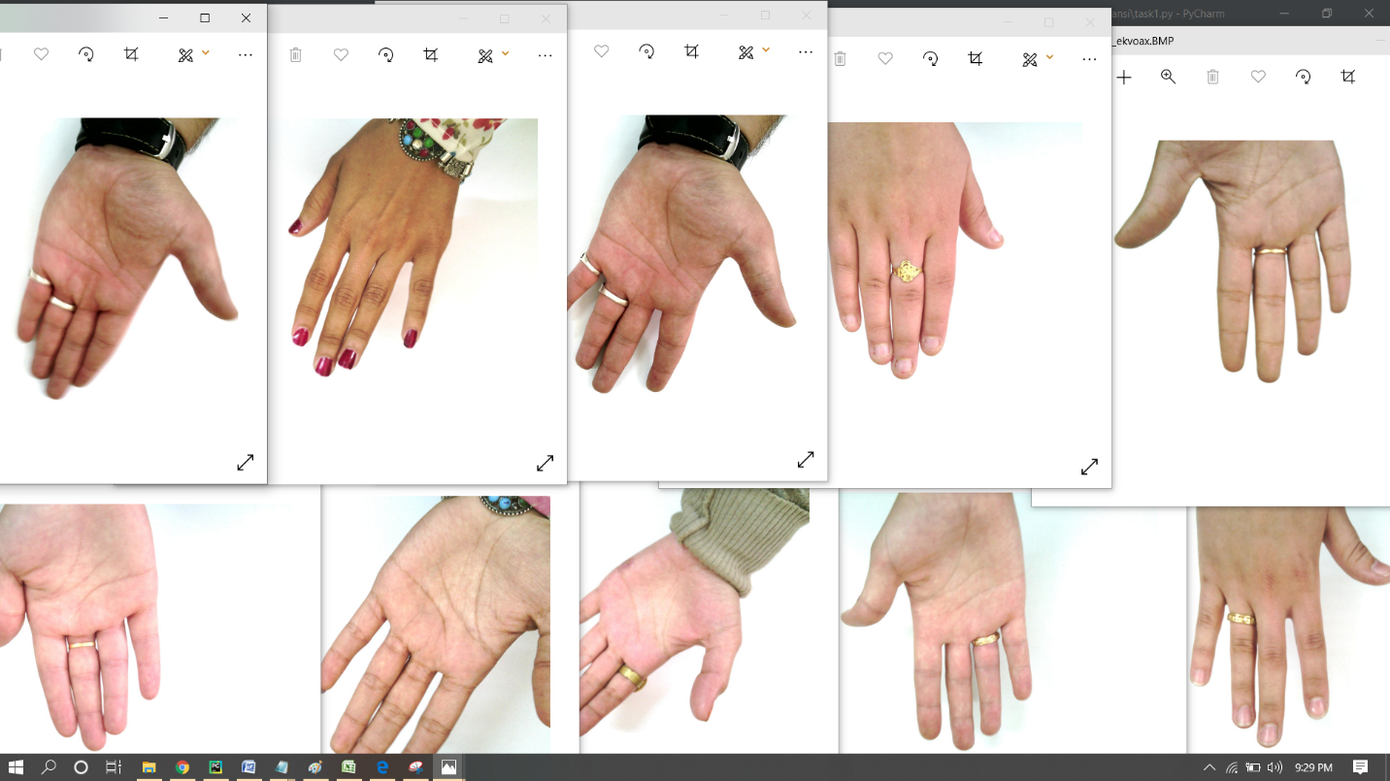

**Task 5**

**Query 1**

Model : LBP K : 10 Label :Right Technique: Non-negative matrix factorization (NMF)

Image ID : Hand_0000111.jpg

System labels image Hand_0000111.jpg as right

**Query 2**

Model : LBP K : 30 Label :Right Technique: Non-negative matrix factorization (NMF)

Image ID : Hand_0000111.jpg

System labels image Hand_0000111.jpg as right

**Query 3**

Model : Sift K : 10 Label : With No Accessories Technique: Singular value decomposition (SVD)

Image ID : Hand_0001395.jpg

System does not label image Hand_0001395.jpg as withoutaccessories

**Query 4**

Model : Sift K : 30 Label : With No Accessories Technique: Singular value decomposition (SVD)

Image ID : Hand_0001395.jpg

System does not label image Hand_0001395.jpg as withoutaccessories

**Task 6**

**Query 1**

Subject ID : 27

Subject_id:41  Score:0.994472  
Subject_id:1506  Score:0.977645  
Subject_id:28  Score:0.974391

**Query 2**

Subject ID : 55

Subject_id:54  Score:0.998718  
Subject_id:1073  Score:0.994667  
Subject_id:505  Score:0.989496

**Task 7**

**Query 1**

K : 10

Refer to the file datasemantic_task7_query1.html in the folder Output/HTML Files.

Refer to the file featuresemantic_task7_query1.html in the folder Output/HTML Files.

**Query 2**

K : 20

Refer to the file datasemantic_task7_query2.html in the folder Output/HTML Files.

Refer to the file featuresemantic_task7_query2.html in the folder Output/HTML Files.

**Task 8**

**Query 1**

K : 4

Refer to the file datasemantic_task8_query1.html in the folder Output/HTML Files.

Refer to the file featuresemantic_task8_query1.html in the folder Output/HTML Files.

**Query 2**

K : 6

Refer to the file datasemantic_task8_query2.html in the folder Output/HTML Files.

Refer to the file featuresemantic_task8_query2.html in the folder Output/HTML Files.